Table of Contents
1: Rationale………………………………………………………………………………………….2
2: Algorithm………………………………………………………………………………………….5
3: Pseudocode………………………………………………………………….…………………..6
4: Flowcharts……………………………………………………………………………………….10
5: Functional Modules…………………………………………………………………………..14
6: Expected Outputs………………………………………………………….………………….15
7: GitHub Evidence…………………………………………………..……….………………….17
8: Conclusion………………………………………………………….……….……………………18
9: References……………………………………………………………………….……………….19

1. Rationale

1.1 Problem Description
Many Community Health Centres (CHCs) and Peripheral Health Units (PHUs) in Sierra Leone register patients on paper and call them in the order they arrive. This first come, first-served approach does not consider how sick a patient is. A child with high fever and fast breathing, a pregnant woman with bleeding, or a patient having convulsions may wait for hours behind patients with minor complaints. Long waits, overcrowding and poorly recorded daily patient numbers are common as a result.
Who is affected: patients (especially children under five, pregnant women and elderly people), nurses and community health officers who must make quick decisions under pressure, and district health managers who need accurate daily data.
Why the problem exists: (1) a shortage of health workers compared with the number of patients; (2) no standard, written triage rule at the registration desk; (3) paper registers that are slow and error prone; (4) limited budgets for commercial software; and (5) unreliable electricity and internet, which discourages complex online systems.

1.2 Background
Sierra Leone’s health system is organised in tiers, with PHUs and CHCs as the first point of contact for most communities. Triage, the process of deciding who needs care first, is a globally recognised practice endorsed by the World Health Organization for emergency and outpatient settings. At small facilities, however, triage often depends on the experience of one busy nurse and is not recorded consistently. A simple, rule based digital queue can support the nurse’s judgement, reduce mistakes and generate a daily report automatically. The system is designed to work offline on a basic computer or phone because connectivity cannot be assumed.

1.3 Proposed Solution
The proposed solution is a logical design for a Digital Patient Queue and Triage Priority System. At registration the health worker enters the patient’s name, age, temperature, whether a danger sign is present (for example convulsions, difficulty breathing or heavy bleeding) and whether the patient is pregnant. The system validates the data, calculates a priority level (1 = Emergency, 2 = Urgent, 3 = Routine), issues a ticket number and places the patient in the correct position in the queue. The nurse can call the next patient, view the current queue and generate an end-of-day report. This assignment presents the design only (algorithm, pseudocode, flowcharts and modules), not source code.

1.4 Computational Thinking Process
Technique | Application in this project
Decomposition | The system is broken into small modules: registerPatient, validateAge, validateTemperature, calculatePriority, insertInQueue, callNextPatient, displayQueue and generateDailyReport.
Pattern recognition | Every patient follows the same pattern: register → validate → classify → queue → be called. Triage rules repeat for every patient, so they are written once as a function.
Abstraction | Details such as screen design, printers and databases are ignored. Only the essential data (age, temperature, danger sign, pregnancy) and rules are kept.
Algorithm design | Clear step-by-step instructions using sequence, selection (IF) and iteration (WHILE, REPEAT, FOR) were written and then converted into pseudocode and flowcharts.

1.5 Algorithm Design Approach
A top down approach was used. The main program runs a menu loop. Each menu option calls one function. Functions that need the same rule (such as priority calculation) are reused. Input is validated inside loops so that impossible values (for example age 150 or temperature 12°C) are rejected before they can affect triage. The queue is kept sorted by priority first and ticket number second, so patients with the same priority are served in order of arrival.

1.6 SDG Alignment
Primary: SDG 3 Good Health and Well-being. Faster identification of emergencies supports target 3.2 (reducing deaths of children under five) and 3.1 (reducing maternal mortality) by ensuring that the sickest patients are seen first.
Secondary: SDG 9 Industry, Innovation and Infrastructure (low cost digital tools for essential services) and SDG 10 Reduced Inequalities (rural and under resourced clinics gain access to the same quality of triage support as larger facilities).

1.7 Open Source Justification
- Why open source: clinics cannot afford licence fees; the logic must be transparent so health workers can trust and audit the triage rules; and no vendor lock in is created.
- Benefits for Sierra Leone: free use and copying across all districts, local customisation (for example Krio or Mende interface text), skills development for local students and developers, and lower long-term maintenance cost.
- Potential community contributions: clinicians can suggest improved triage thresholds, students can translate the interface or write tests, developers can add SMS alerts or offline synchronisation, and the Ministry or NGOs can contribute documentation and training material.

1.8 Digital Public Goods Justification
A Digital Public Good (DPG) is open source software, open data or open content that adheres to privacy and other applicable laws and best practices, does no harm, and helps attain the SDGs. The system could qualify by: releasing its design and future code under an open licence (for example MIT or GPL); using open standards so data can be exported to national health platforms such as DHIS2, which is already widely used in health information systems in Sierra Leone; protecting patient privacy by storing only minimal data and supporting anonymised reporting; and being documented clearly for adoption by any government or NGO. It promotes accessibility (works offline on low-cost devices), openness (public code and rules) and public benefit (free for all health facilities).

1.9 Sierra Leone Community Impact
- Problem solved: unfair and unsafe waiting at health centres, and unreliable patient records.
- Expected impact: emergency patients are identified immediately; waiting becomes more transparent; nurses spend less time on registers; managers receive accurate daily totals for planning medicines and staff.
- Beneficiaries: patients and families, nurses and community health officers, district health management teams and the Ministry of Health.
- Long-term sustainability: no licence costs, runs on low cost hardware, community maintained through GitHub, and can be taught in training colleges so that local people can support it.

2. Algorithm

2.1 Input, Processing and Output
Stage | Description
Input | Menu choice; patient name; age; temperature (°C); danger sign (TRUE/FALSE); pregnant (TRUE/FALSE).
Processing | Validate age and temperature; evaluate Boolean conditions; calculate priority; generate ticket number; insert patient in sorted queue; update counters.
Output | Ticket number, priority label, queue position; current queue list; called patient details; daily summary report; error messages.

2.2 Variables, Constants and Data Types
Name | Data type | Purpose
MAX_QUEUE = 100 | Integer (constant) | Maximum patients per day
MIN_AGE = 0, MAX_AGE = 120 | Integer (constant) | Valid age range
MIN_TEMP = 34.0, MAX_TEMP = 43.0 | Real (constant) | Valid temperature range (°C)
FEVER_TEMP = 38.0 | Real (constant) | Fever threshold
EMERGENCY_TEMP = 39.5 | Real (constant) | Very high fever threshold
CHILD_AGE = 5, ELDERLY_AGE = 65 | Integer (constant) | Age limits for vulnerable groups
name | String | Patient name
age | Integer | Patient age in years
temp | Real | Body temperature
hasDangerSign, isPregnant | Boolean | Clinical flags
isEmergency, isVulnerable | Boolean | Results of Boolean logic in calculatePriority
priority, ticketCounter, servedCount | Integer | Triage level, ticket numbering, number of patients served
queue | Array of records | Waiting patients (ticket, name, priority)
running | Boolean | Controls main loop

2.3 Step by Step Algorithm
- Start the program and define all constants.
- Create an empty queue, set ticketCounter = 0, servedCount = 0 and running = TRUE.
- While running is TRUE, display the menu and read the user’s choice.
- If choice is 1 (Register patient): check that the queue is not full; read the name; repeatedly read the age until it is within MIN AGE and MAX AGE; repeatedly read the temperature until it is within MIN TEMP and MAX TEMP; read danger sign and pregnancy.
- Call calculatePriority using age, temperature, danger sign and pregnancy to obtain priority 1, 2 or 3.
- Increase ticketCounter by 1 and create a patient record.
- Insert the record into the queue after the last patient of equal or higher priority, then display the ticket, priority and position.
- If choice is 2 (Call next patient): if the queue is empty, display a message; otherwise remove the first patient, display their details and increase servedCount.
- If choice is 3 (Display queue): loop through the queue and display every waiting patient.
- If choice is 4 (Daily report): count patients by priority and display totals and the percentage of emergencies.
- If choice is 5 (Exit): set running = FALSE. For any other value, display “Invalid choice”.
- When running becomes FALSE, display a goodbye message and stop.
3. Pseudocode

3.1 Main Program
START Main
CONSTANT MAX QUEUE = 100, MIN AGE = 0, MAX AGE = 120
CONSTANT MIN TEMP = 34.0, MAX TEMP = 43.0
CONSTANT FEVER TEMP = 38.0, EMERGENCY TEMP = 39.5
CONSTANT CHILD_AGE = 5, ELDERLY AGE = 65
SET queue = empty list
SET ticketCounter = 0, servedCount = 0
SET running = TRUE
WHILE running = TRUE DO
CALL displayMenu()
INPUT choice
IF choice = 1 THEN
CALL registerPatient()
ELSE IF choice = 2 THEN
CALL callNextPatient()
ELSE IF choice = 3 THEN
CALL displayQueue()
ELSE IF choice = 4 THEN
CALL generateDailyReport()
ELSE IF choice = 5 THEN
SET running = FALSE
ELSE
OUTPUT "Invalid choice. Enter 1 to 5."
END IF
END WHILE
OUTPUT "System closed. Stay safe."
END Main

3.2 Function: registerPatient
FUNCTION registerPatient()
IF size(queue) >= MAX QUEUE THEN
OUTPUT "Queue full. Refer patient to nearest facility."
RETURN
END IF
INPUT name
REPEAT
INPUT age
IF age < MIN AGE OR age > MAX AGE THEN
OUTPUT "Invalid age. Try again."
END IF
UNTIL age >= MIN AGE AND age <= MAX AGE
REPEAT
INPUT temp
IF temp < MIN TEMP OR temp > MAX TEMP THEN
OUTPUT "Invalid temperature. Try again."
END IF
UNTIL temp >= MIN TEMP AND temp <= MAX TEMP
INPUT hasDangerSign, isPregnant
SET priority = calculatePriority(age, temp, hasDangerSign, isPregnant)
SET ticketCounter = ticketCounter + 1
SET patient = (ticketCounter, name, age, priority)
CALL insertInQueue(patient)
OUTPUT "Ticket", ticketCounter, "Priority", priority
END FUNCTION

3.3 Function: calculatePriority
FUNCTION calculatePriority(age, temp, hasDangerSign, isPregnant)
SET isEmergency = hasDangerSign OR temp >= EMERGENCY TEMP
OR (age < CHILD AGE AND temp >= FEVER TEMP)
SET isVulnerable = isPregnant OR age < CHILD AGE OR age >= ELDERLY AGE
IF isEmergency = TRUE THEN
RETURN 1
ELSE IF isVulnerable = TRUE OR temp >= FEVER TEMP THEN
RETURN 2
ELSE
RETURN 3
END IF
END FUNCTION

3.4 Function: insertInQueue
FUNCTION insertInQueue(patient)
SET position = size(queue) + 1
FOR i = 1 TO size(queue) DO
IF queue[i].priority > patient.priority THEN
SET position = i
EXIT FOR
END IF
END FOR
INSERT patient INTO queue AT position
OUTPUT "Queue position:", position
END FUNCTION

3.5 Functions: callNextPatient, displayQueue, generateDailyReport
FUNCTION callNextPatient()
IF size(queue) = 0 THEN
OUTPUT "No patients waiting."
ELSE
SET next = queue[1]
REMOVE queue[1]
SET servedCount = servedCount + 1
OUTPUT "Now calling Ticket", next.ticket, next.name
END IF
END FUNCTION

FUNCTION displayQueue()
IF size(queue) = 0 THEN
OUTPUT "Queue is empty."
ELSE
FOR EACH p IN queue DO
OUTPUT p.ticket, p.name, priorityLabel(p.priority)
END FOR
END IF
END FUNCTION

FUNCTION generateDailyReport()
SET p1 = 0, p2 = 0, p3 = 0
FOR EACH p IN queue DO
IF p.priority = 1 THEN p1 = p1 + 1
ELSE IF p.priority = 2 THEN p2 = p2 + 1
ELSE p3 = p3 + 1
END IF
END FOR
OUTPUT "Registered today:", ticketCounter, "Served:", servedCount
OUTPUT "Still waiting - P1:", p1, "P2:", p2, "P3:", p3
IF ticketCounter > 0 THEN
OUTPUT "Emergency share:", (total of P1 registered / ticketCounter) * 100, "%"
END IF
END FUNCTION

4. Flowcharts
Symbols: rounded rectangle = start/end; parallelogram = input/output; rectangle = process; diamond = decision; double-bordered rectangle = call to a function/module.

4.1 Main Program Flowchart
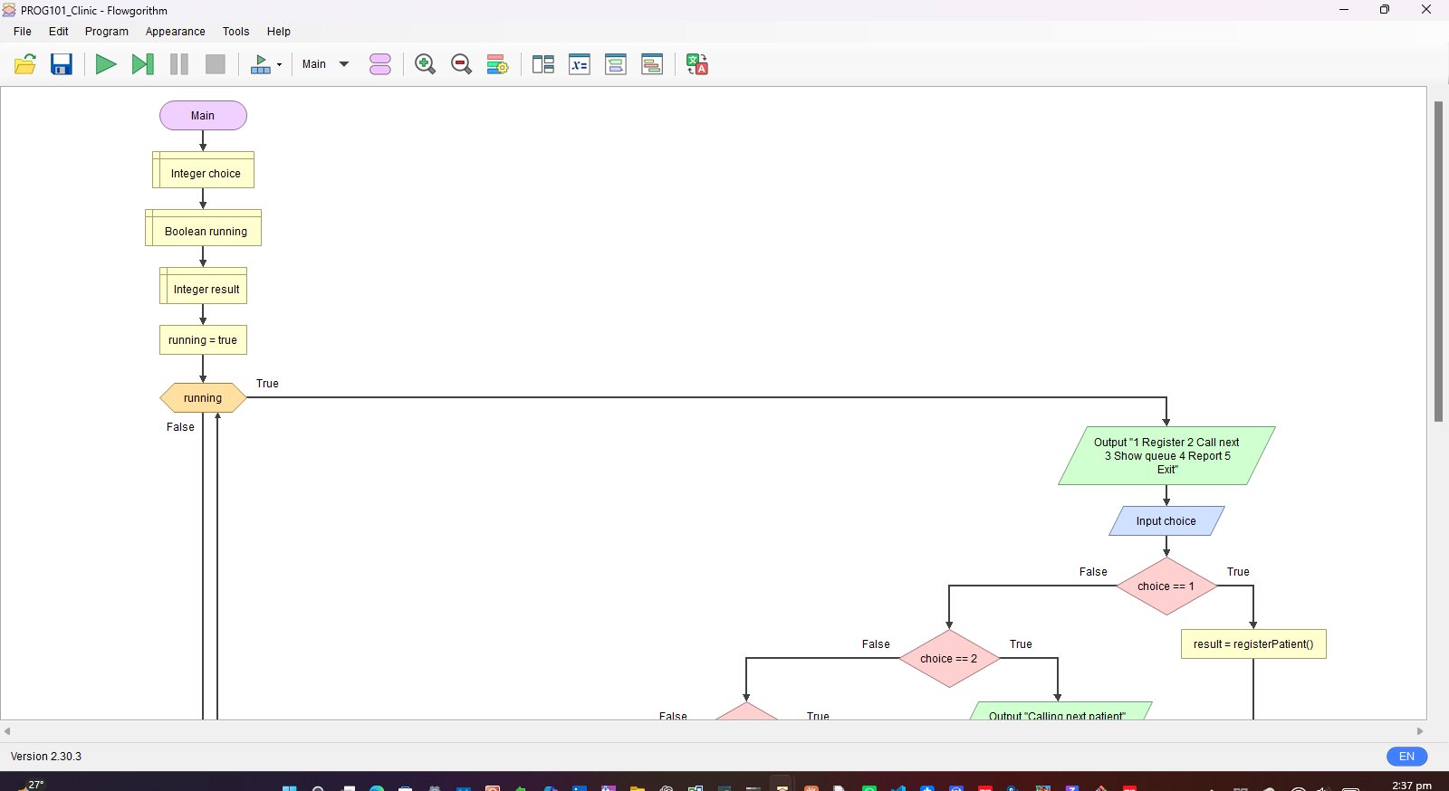

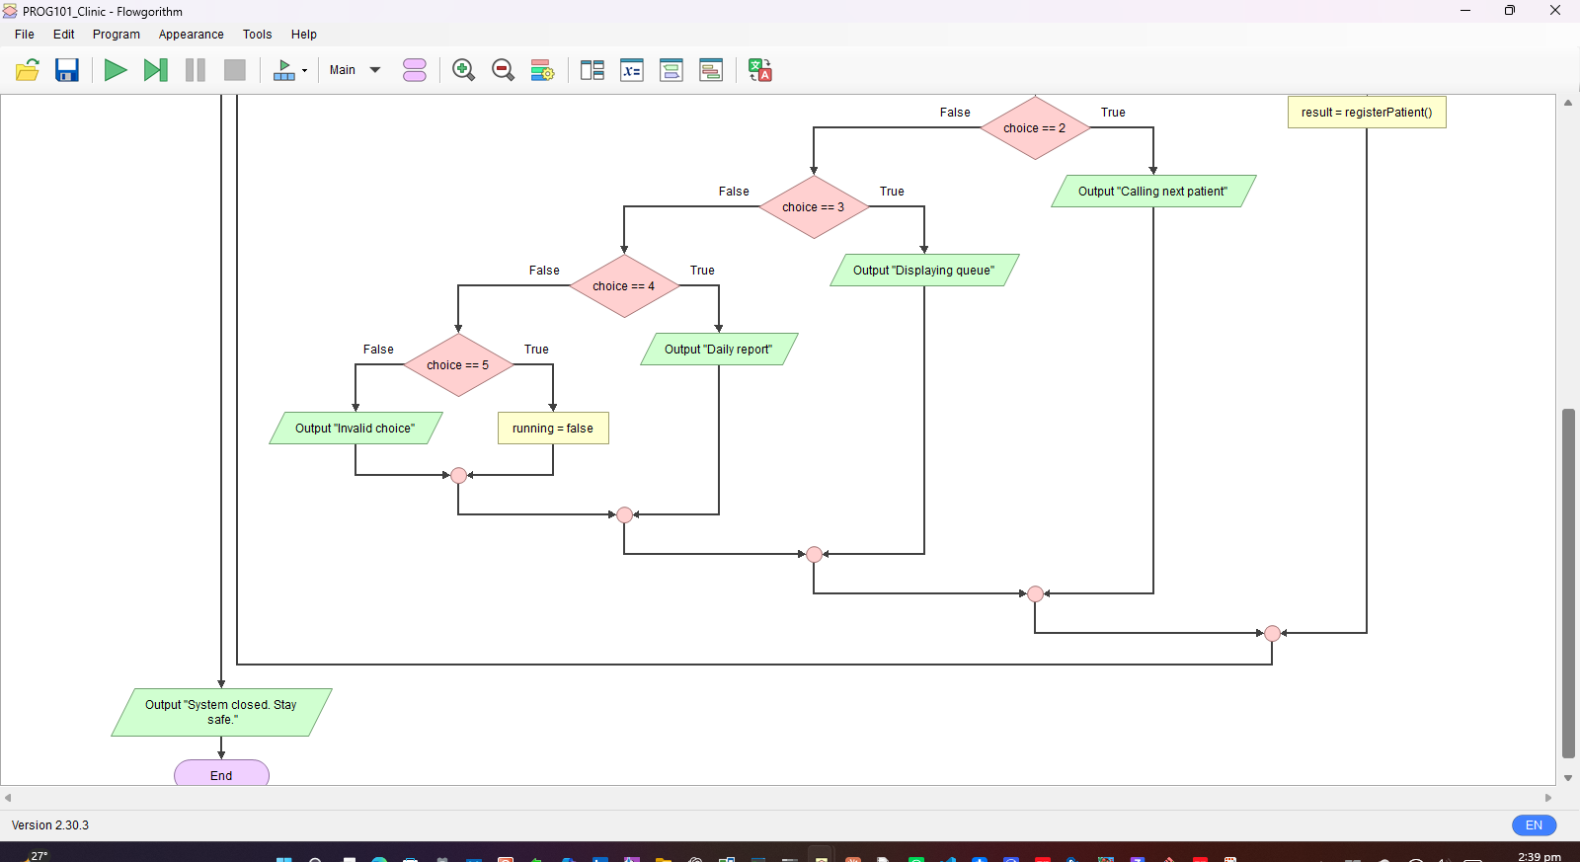

4.2 calculatePriority Flowchart
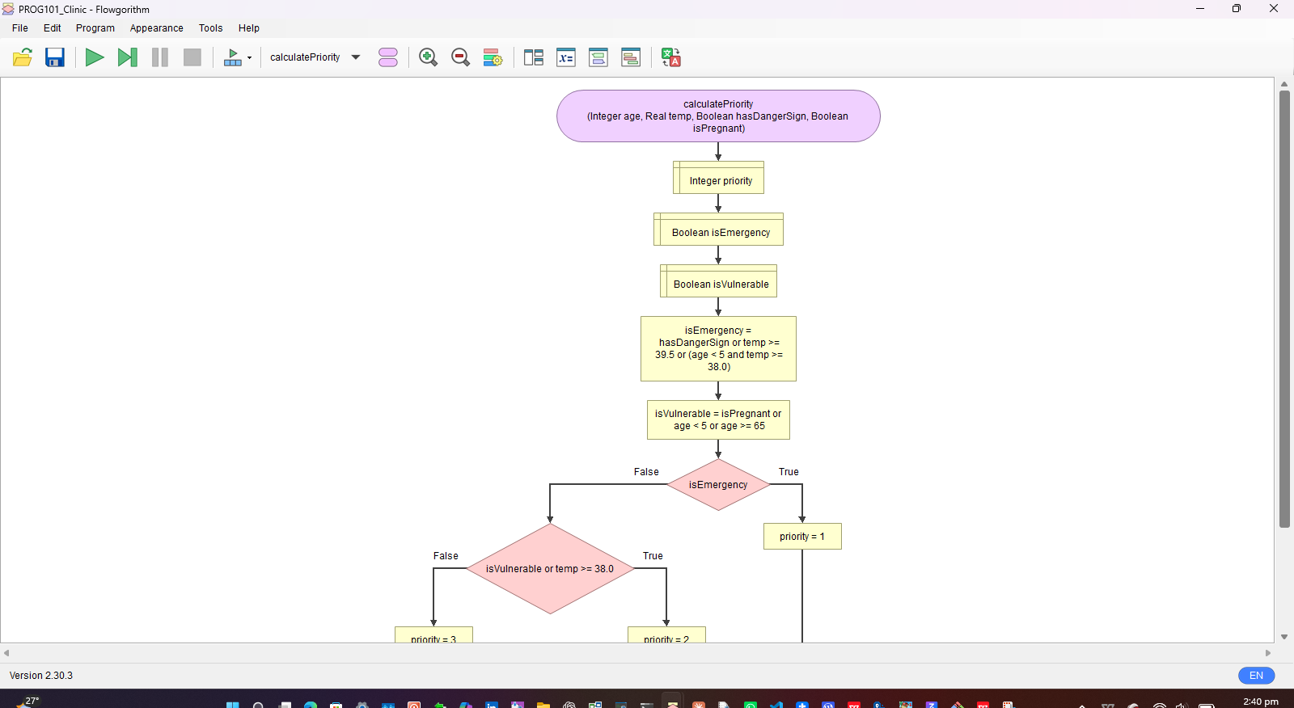

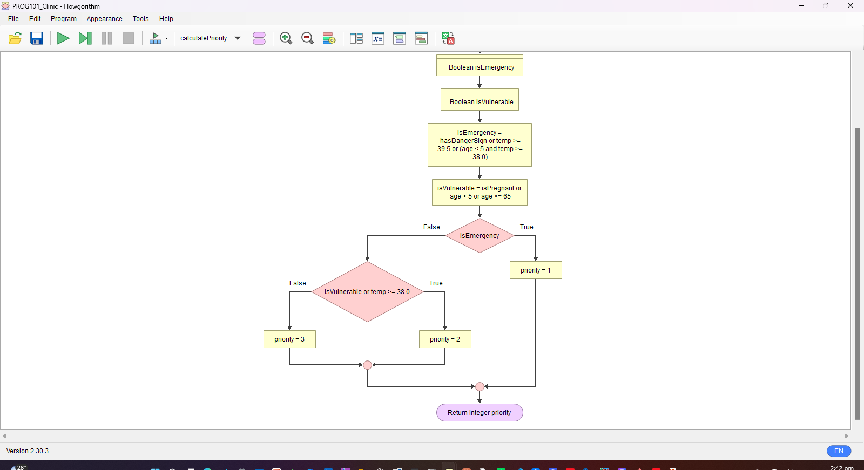

4.3 registerPatient Flowchart
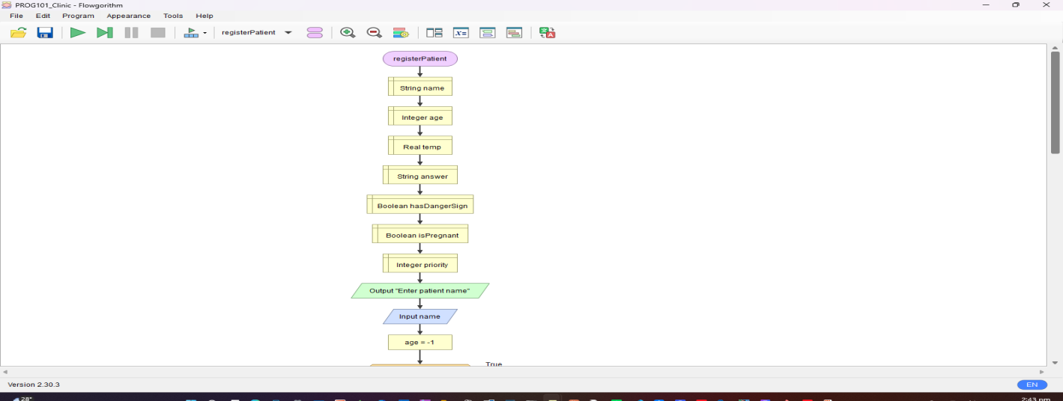
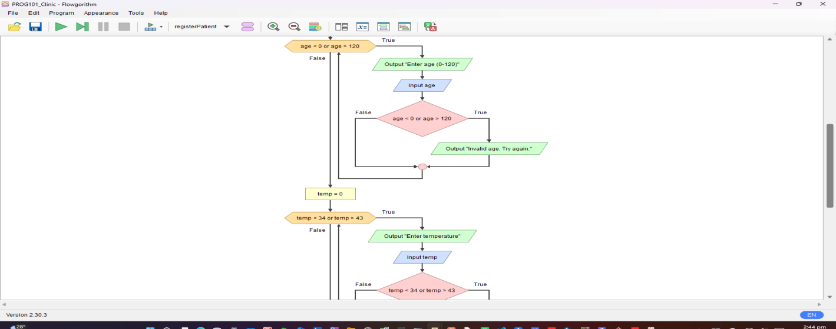

5. Functional Modules
Module | Purpose | Inputs | Outputs / Returns
displayMenu() | Shows options 1–5 | None | Menu text
registerPatient() | Collects and validates data, creates ticket | Keyboard input | Ticket, priority, position
calculatePriority() | Applies triage rules using Boolean logic | age, temp, hasDangerSign, isPregnant | Priority 1, 2 or 3
insertInQueue() | Places patient by priority then arrival | patient record | Updated queue, position
callNextPatient() | Serves the first patient in queue | Queue | Patient details
displayQueue() | Lists all waiting patients | Queue | List on screen
generateDailyReport() | Summarises the day | Queue, counters | Report totals
priorityLabel() | Converts 1/2/3 to text | priority | "EMERGENCY", "URGENT", "ROUTINE"

5.1 Logic Concepts Demonstrated
- Decision structures: IF / ELSE IF / ELSE in the menu and priority function.
- Repetition structures: WHILE (menu), REPEAT…UNTIL (validation), FOR and FOR EACH (queue handling).
- Boolean logic: AND, OR and comparison operators in isEmergency and isVulnerable.
- Functions and modules: each task is separated so it can be reused and tested independently.
- Problem decomposition: one large problem divided into eight smaller ones.

6. Expected Outputs

6.1 Priority Calculation Test Scenarios
# | Patient | Age | Temp | Danger sign / Pregnant | Priority | Reason
1 | Amara | 3 | 38.6 | No / No | 1 (EMERGENCY) | Child under 5 with fever (age < 5 AND temp ≥ 38.0)
2 | Fatmata | 28 | 37.2 | No / Yes | 2 (URGENT) | Pregnant, no emergency signs
3 | Mohamed | 35 | 36.8 | No / No | 3 (ROUTINE) | No emergency or vulnerability
4 | Ibrahim | 52 | 37.0 | Yes / No | 1 (EMERGENCY) | Danger sign present
5 | Kadiatu | 70 | 37.5 | No / No | 2 (URGENT) | Age ≥ 65

6.2 Sample Run: Registration and Queue Order
Choice: 1 Name: Amara Age: 3 Temp: 38.6 Danger: FALSE Pregnant: FALSE
>> Ticket 1 | Priority 1 (EMERGENCY) | Queue position: 1
Choice: 1 Name: Fatmata Age: 28 Temp: 37.2 Danger: FALSE Pregnant: TRUE
>> Ticket 2 | Priority 2 (URGENT) | Queue position: 2
Choice: 1 Name: Mohamed Age: 35 Temp: 36.8 Danger: FALSE Pregnant: FALSE
>> Ticket 3 | Priority 3 (ROUTINE) | Queue position: 3
Choice: 1 Name: Ibrahim Age: 52 Temp: 37.0 Danger: TRUE Pregnant: FALSE
>> Ticket 4 | Priority 1 (EMERGENCY) | Queue position: 2

Choice: 3 (Display queue)
1. Ticket 1 Amara EMERGENCY
2. Ticket 4 Ibrahim EMERGENCY
3. Ticket 2 Fatmata URGENT
4. Ticket 3 Mohamed ROUTINE

Choice: 2 (Call next) >> Now calling Ticket 1 - Amara
Choice: 2 (Call next) >> Now calling Ticket 4 - Ibrahim

6.3 Validation and Error Scenarios
Scenario | Input | Expected output
Invalid age | Age = 150 | "Invalid age. Try again." and age is requested again
Invalid temperature | Temp = 12 | "Invalid temperature. Try again." and temp is requested again
Empty queue | Choice 2 with no patients | "No patients waiting."
Queue full | 101st patient | "Queue full. Refer patient to nearest facility."
Wrong menu option | Choice = 9 | "Invalid choice. Enter 1 to 5."

6.4 Daily Report (after the sample run above)
Registered today: 4 Served: 2
Still waiting - P1: 0 P2: 1 P3: 1
Emergency share: 50 %

7. GitHub Evidence
Insert the evidence below before printing. Replace each placeholder with a real screenshot or text.
Item | Evidence
GitHub Repository | PROG101_Assignment_Matthew-Junior-Boima_905005787
Repository URL | https://github.com/matthewjuniorboima-cloud/PROG101_Assignment_matthewjuniorboima_905005787
Git Commit History | [Paste screenshot of the Commits page or output of: git log --oneline]
README.md | PROG101_Assignment_Matthew-Junior-Boima_905005787

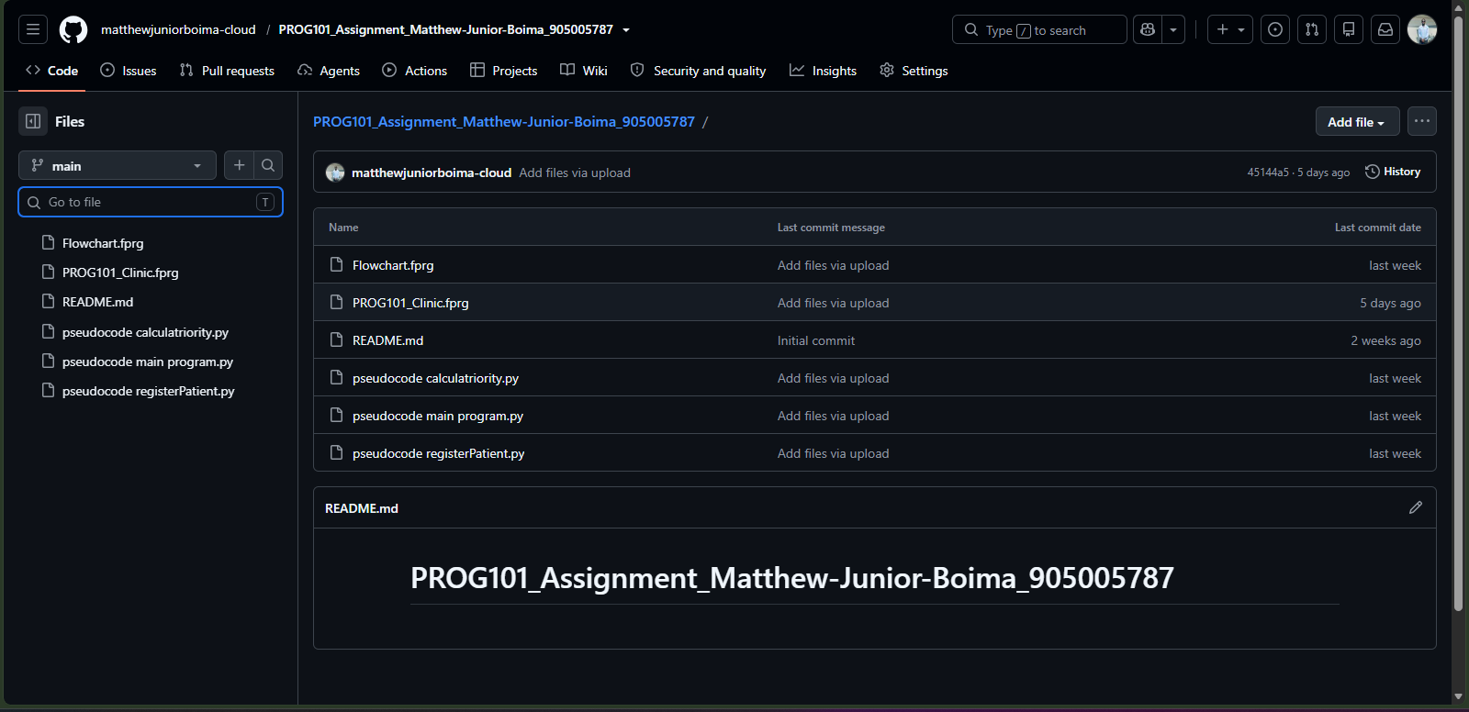

Conclusion

In many health centres in Sierra Leone, patients are still seen in the order they arrive. That sounds fair, but it can be dangerous. A baby with a high fever or a pregnant woman with a warning sign may sit and wait behind someone with a mild cough. This project set out to fix that problem with a simple, logical design.

My system asks a few quick questions at registration: age, temperature, any danger signs, and whether the patient is pregnant. From the answers, it decides who is an emergency, who is urgent and who can wait a little longer. I found that breaking the problem into small parts made it much easier to handle. Each part, such as registering a patient or working out priority, became its own module that I could plan, draw and test separately.

Building the flowcharts in Flowgorithm taught me a lot. I made mistakes along the way, like a wrong data type and a missing branch, but fixing them helped me understand how decisions and loops really work. Seeing the right priority appear when I tested Amara's details was a satisfying moment.

The project supports SDG 3, Good Health and Well being, because it helps the sickest people get care first. I believe it should be open source so that clinics in every district can use it for free, change it to suit their needs, and improve it together. In the future, it could grow into a full application that works offline and connects to national health reporting. Even as a design only, it shows how clear thinking can help solve real problems in our communities.

Tips

The line about "my mistakes" is only true if it matches what you actually did, so change it if needed.

Keep it in the first person, as it is here.

References
- World Health Organization (WHO). Emergency Triage Assessment and Treatment (ETAT) guidelines. https://www.who.int
- United Nations. Sustainable Development Goals, Goal 3: Good Health and Well-being. https://sdgs.un.org/goals/goal
- Digital Public Goods Alliance. The DPG Standard. https://digitalpublicgoods.net/standard/
- Open Source Initiative. The Open Source Definition. https://opensource.org/osd
- DHIS2. Open-source health information platform. https://dhis2.org
- Limkokwing University of Creative Technology, Sierra Leone. PROG101 Assignment Brief, September 2026.
- Flowgorithm. Flowchart programming language. http://www.flowgorithm.org

